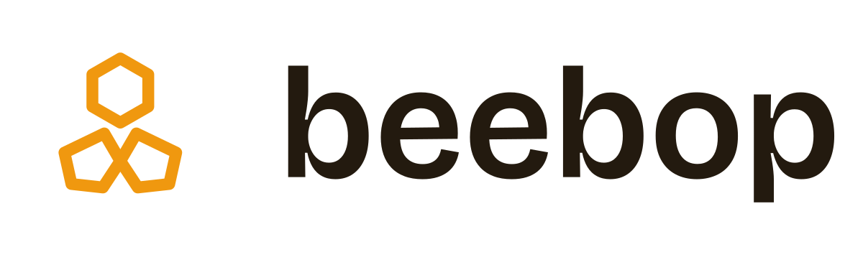
Brand & Logo Specification
The triad mark, usage rules, palette, and assets
Version 1.0
Verified homes in Abuja

The mark
WHAT IT IS
The Beebop logo is the triad: three hollow hexagonal cells arranged in rotational symmetry — one pointing up, two splayed below — drawn in a single consistent line weight. It reads as a fragment of honeycomb, and therefore as a hive: a place where many verified homes are gathered and kept. It carries the brand's bee-and-honey idea without ever drawing a literal bee.
The rotational symmetry is deliberate. It gives the mark a calm, balanced center of gravity rather than the restless feel of an offset cluster, and it lets the logo spin cleanly as a loading animation. The three cells also quietly suggest gathering and community — many cells, one comb.

Primary horizontal lockup
THE ONE RULE THAT MATTERS MOST
The cells are always hollow. The open centers are what make the mark read as honeycomb. Never fill them with solid color — a filled triad becomes a generic badge and loses its entire meaning. The only thing that changes between sizes is the stroke weight, which steps up as the mark gets smaller so the cells stay open and legible.

Lockups
The logo comes in three arrangements. Use the one that best fits the space; never re-space or re-typeset the wordmark yourself.

Horizontal — the default
Mark plus wordmark, side by side. This is the primary lockup for website headers, email signatures, letterheads, and most horizontal spaces. The mark and wordmark are optically centered on a shared midline with a fixed gap; that relationship is locked.

Stacked
Mark above the wordmark, centered. Use in square or vertical spaces — social profile headers, posters, splash screens, merchandise.

Mark alone
The triad on its own. This is the avatar, the app icon, and the favicon. Use it anywhere the brand is already established or space is tight.

The wordmark
The wordmark is always set in lowercase — beebop, never “BeeBop” or “Beebop.” Lowercase is the friendlier, more modern register that matches the conversational, chat-first product. This settles any earlier inconsistency: one casing, everywhere. The display face is Bricolage Grotesque, SemiBold.

Color variants
Four approved renderings cover every background. Always choose the variant with the strongest contrast against its ground.
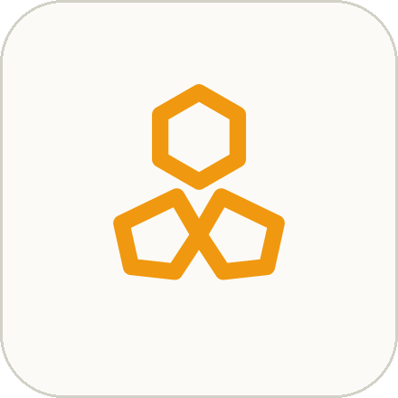  Honey on light | 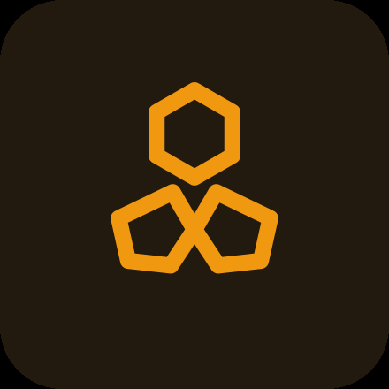  Honey on dark | 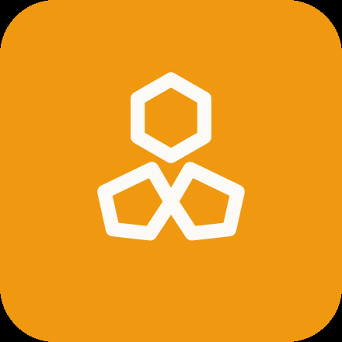  Knockout on honey | 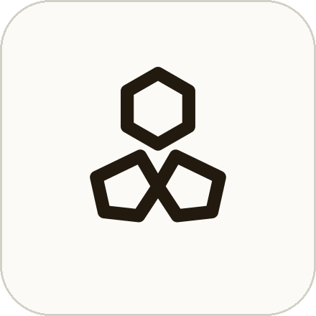  One-color (mono)

- Honey on light — the standard mark for any light or white background.
- Honey on dark — the same honey mark on Hive Black or dark imagery.
- Knockout on honey — Paper-colored mark reversed out of a honey ground — used for app icons and honey-filled buttons.
- One-color — a single Hive Black version for situations where color can’t be used: faxes, embossing, single-color print, watermarks.

Size range & the favicon
The triad holds from a hero banner down to roughly 24px because its stroke weight increases as it shrinks. Below that, three hollow cells become too small to keep their open centers, so the favicon simplifies to a single cell — unmistakably part of the same comb system, and perfectly clear at 16px.
  32px and up — full triad |   16px — single cell

- 32px / 48px favicon — full triad, honey, increased stroke weight.
- 16px favicon — one hollow hexagon cell — the simplest expression of the system.
Minimum sizes: the mark is never shown below 16px; the full horizontal lockup is never shown below 120px wide (use the mark alone in tighter spaces).

Clear space
Keep a margin of empty space around the logo equal to the height of one hexagon cell on all four sides. Nothing — no text, image edge, button, or competing graphic — should intrude into that zone. When in doubt, give it more room; the mark reads best with air around it.

Palette
Five colors carry the entire brand. The logo and the product UI share this exact system, so they always speak the same language.
 | Honey  #F0980F | The mark, primary buttons, links, and active states. The brand's signature color.
 | Hive Black  #231A0F | The wordmark and all body text. A warm near-black, never pure #000.
 | Paper  #FCFAF6 | Backgrounds and knockout fills. A barely-warm off-white so cards sit on it cleanly.
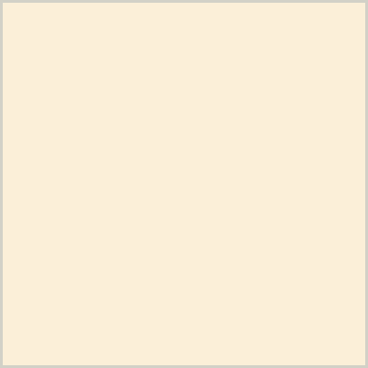 | Nectar  #FBEFD8 | Soft honey tint for chat user-bubbles, hover states, and quiet highlights.
 | Verified Blue  #1D4ED8 | Reserved exclusively for the verification badge. One color, one meaning.
Why blue is reserved: verification is Beebop’s core promise. Keeping one color tied to one meaning makes the badge instantly recognizable and trustworthy — so Verified Blue is never used for decoration, links, or anything else.

Typography

Display — Bricolage Grotesque
Used for the wordmark, headlines, section headings, and listing names. A grotesque with genuine character — slightly condensed and warm — that gives Beebop a voice a neutral corporate sans never would. Use it with restraint, at SemiBold or Bold, tight line-height, and a touch of negative letter-spacing.

Body — Instrument Sans
Used for interface text, messages, descriptions, and captions. Friendly and highly legible at small sizes. Turn on its tabular numerals for every price, so figures like ₦1,200,000 align digit-for-digit — prices are data, and data deserves typographic discipline.
Type scale: five sizes, used everywhere with no strays — roughly 13 (captions, eyebrows), 15 (body, messages), 17 (card titles), 22 (section heads), 34 (hero). A disciplined scale is half of what makes an interface feel calm.
Both faces are free on Google Fonts. Sentence case is the default everywhere; avoid Title Case and ALL CAPS in the interface.

Misuse — never do this
The integrity of the mark depends on a few firm rules. Each of these breaks it:
- No fill — Don’t fill the cells with solid color. The hollow centers are the whole idea.
- No stretching — Don’t stretch, squash, or distort the proportions. Scale uniformly.
- No off-brand color — Don’t recolor the mark outside the approved variants — no off-brand colors, gradients, or photos inside the cells.
- No rotation — Don’t rotate or tilt the mark. It sits upright. (Rotation is reserved for the deliberate spin of the loading animation only.)
- No effects — Don’t add drop shadows, glows, bevels, or outlines.
- No redrawing — Don’t re-typeset or re-space the wordmark, or pair the mark with a different font.
- No clutter — Don’t place the logo on a busy background or a low-contrast color. Give it a clean ground.

Motion
The triad’s rotational symmetry makes it a natural loading and “thinking” animation. In the chat product, the three cells can rotate slowly or fill with honey one by one while the assistant searches for verified homes — turning a wait into a small, on-brand moment that says “the hive is working for you.” Keep it gentle: one orchestrated motion, never frantic, and always respecting reduced-motion settings.

Asset files
The accompanying asset folder contains everything needed to ship the mark. The SVG masters are the source of truth — scale infinitely and should be used wherever possible.

Vector (SVG)
- beebop-lockup-horizontal.svg — the master horizontal lockup (honey mark, Hive Black wordmark).
- beebop-lockup-horizontal-dark.svg — lockup for dark backgrounds (honey mark, Paper wordmark).
- beebop-mark-*.svg — the triad mark alone, in honey, mono, and knockout.
- beebop-wordmark-*.svg — the wordmark alone, in mono and knockout.
- beebop-favicon*.svg — the 32px+ full-triad favicon and the 16px single-cell favicon.

Raster (PNG) & icons
- assets/png/ — transparent mark PNGs from 32px to 1024px, plus lockup PNGs.
- assets/favicon/ — favicon.ico (multi-resolution), PNG favicons, apple-touch-icon, and PWA icons.
- assets/app-icon/ — rounded app icons on honey and dark grounds, 180–1024px.

Web install
The favicon folder includes favicon-head-snippet.html (drop the tags into your <head>) and site.webmanifest (pre-filled with Beebop’s name and theme colors) for PWA install.
Beebop — Brand & Logo Specification, v1.0
Note: before printing or filing, run a trademark and reverse-image check for the mark in your category — a legal step, not a design one.

